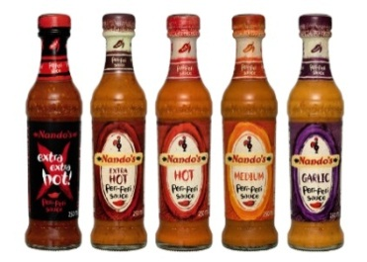
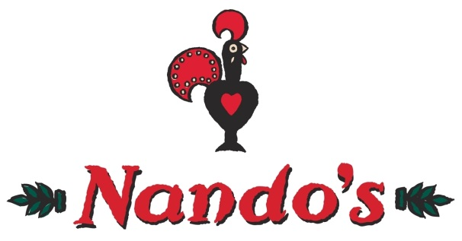
Take Away Homework!

Unit 1 –Choose your homework from the menu below:
The Peri-ometer suggests the difficulty or challenge the
homework may offer.

Choose 2 businesses and analyse the strengths and weaknesses of both to identify a gap in the market.  Quality vs quantity… | Do you think opening a shop to sell your products is a calculated risk?  Explain your answer fully and provide a justification for your reason….. | Explain how cash flow problems can lead to business failure.  You have to include the keywords “stock levels” and “credit terms” in your answer….. | Create an 8 stage flowchart to show the recruitment process,  Extra sauce required – quote 3 pieces of recruitment legislation… | Explain what stage of the business cycle you think the UK is currently in?  How is this affecting small businesses?
Create a market map for the fast food industry. Now identify a gap in the market.  Make it eye catching by adding logos… | Why does “creative thinking” give businesses competitive advantage?  Try googling it if you can’t remember what it is… | Make a poster to show the formula for how profit is calculated,  Give some numerical examples… | Make a table to show the advantages and disadvantages of limited and unlimited liability,  Think sole trader vs private limited company… | Make a factsheet to show how food manufacturers might be affected by exchange rates.  Use the keywords “import” and “export”….
On a post-it-note define “added value” giving examples for 1 business.  Think of a small local business that you know or visit regularly… | Make a mind map of the 4 W questions to ask before starting a business.  Write a sentence to explain why they might ask them. | Create a poster to show 8 different sources of finance that a business can use.  Use key terms, use pictures and examples to make it eye catching… | Make a spider diagram to show at least 8 different stakeholders in a business.  Add extra sauce by explaining why they are stakeholders and use an example business…. | Design 3 exam questions to calculate interest rates for a loan of £10000.  Make sure you make an answer sheet too!
Create a mind map identifying at least 5 different types of primary and secondary research.  Use key terms, make it informative and eye catching… | Describe the difference between invention and innovation.  Find the definitions of these and create a keyword book to help you to learn how they help businesses… | Write 2 Tweets that could describe fixed and variable costs.  No more than 140 characters; use #’s for key words and they must be informative… | Make a revision card on the 4Ps. State each one and write a sentence to describe what they are.  Revision cards can be made on scraps of paper or even an empty box… | Make a list of 5 commodities and give an example of the type of business that would us them.  What happens if the price goes up…or down….?

