Choose 2 businesses and analyse how they make themselves more competitive.  Can you provided evidence to show these methods have worked … | Quality control V Quality assurance which is best for a business? Discuss  Try googling some examples of businesses that use each to develop your answer… | How does a business improve its cash flow? Discuss.  You have to include the keywords “inflows” and “outflows” and “long term” and “short term” in your answer….. | How could a centralised structure benefit a business? Discuss  Make sure you use the following words in your explanation “it depends on”, “ chain of command”, and “ decision making” | Assess the extent to which an ethical image might determine a company’s success.  Can you provide real life examples to enhance you work…
Draw a stock control graph, labelling the maximum stock, minimum stock levels, and he reorder level  Create two exams questions about it … | Make a poster to show the definition and advantages and disadvantages of JIT.  Why might it not be suitable for some businesses… | Create a table which shows the advantages and disadvantages of the different methods of remuneration.  Can you also add the definitions of freelance and temporary workers to your sheet…. | Make a factsheet to explain the economic issues affecting international trade  Rember to use the following terms, icome distribution, import protection, export subsidy, quotas, export subsidies, protectionist policies, tariffs.. | Draw a diagram to show the breakeven point. All lines should be labelled.  Draw on a margin of safety…
Draw a product life cycle graph and label it.  Think of a business that you know or visit regularly and put their products on it.… | Make a spider diagram to show at least 8 different methods a business could use to help improve quality.  Add extra sauce by explaining how the methods will improve the quality of the business | Create a mind map to demonstrate the different ways a business could improve its profit.  Make sure key terms are defined … | Draw MAslows hierarchy of needs and exaplin how a business can meet each of these needs  Google real life business so you can see examples in real life to add to your diagram … | Create a poster with all the keywords and definitions for organisational structures.  Draw some examples of to illustares the words if you can …
Create a mind map to show at least 5 different ways a business could encourage customers to have a repeat purchase. Use key terms, make it informative and eye catching… | Describe the 3 different elements of the design mix.  Use a business you know to describe to give examples… | Write 2 Tweets that could describe margin of safety and breakeven point.  No more than 140 characters; use #’s for key words and they must be informative… | Make a revision card on the Boston Matrix. State each category and write a sentence to describe what they are.  Revision cards can be made on scraps of paper or even an empty box… | Make a list of 5 ways a business could make themselves ore competitive  Explain how these methods make them more competitive..
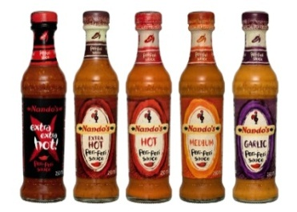
Take Away Homework - Unit 3
Choose your homework from the menu below:
The Peri-ometer suggests the difficulty or challenge the homework may offer.

