**Topic 3.3 Effective Financial Management**

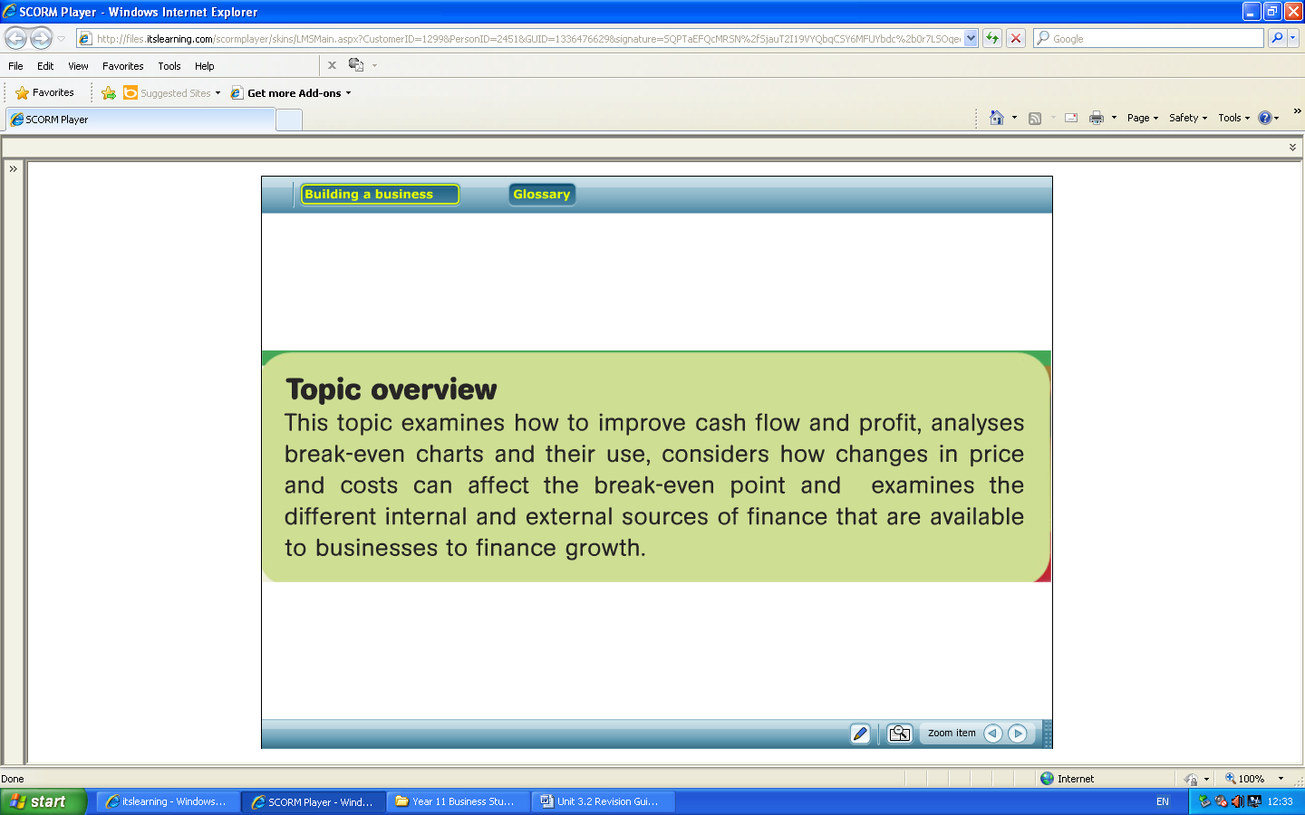

The Key Areas

* How to improve Cash Flow
* How to improve Profit
* Break Even Charts and Break Even Analysis
* Financing Growth

How to Improve Cash Flow

Define Cash Flow:

What is the difference between cash inflows and cash outflows?

Explain the following Key Terms:

Destocking: ______________________________________________________________________________________________________

Trade Credit:

Revision Questions:

1. Explain the use/purpose of a cash flow forecast for a business
2. Name 5 inflows and outflows for a business
3. Be able to complete a cash flow forecast
4. Be able to read a cash flow forecast and comment on why the business may have a positive or negative cash flow balance
5. Be able to suggest how a business can improve its inflows and reduces its outflows for the long and short term

Previous Exam Questions

|  |
| --- |
| *Range* is a national chain of discount stores in the UK which has expanded rapidly. It sells a variety of products from furniture to stationery. From October of each year a quarter of each store’s floor space is used to stock Christmas products such as Christmas trees, lights and decorations. To do this *The Range* de-stocks its summer products, such as garden furniture and barbecues. This involves selling off its summer products at lower prices. |

(a) Which of the following is a cash inflow? (1 mark)

Select **one** answer.

**A** Payments to suppliers.

**B** Purchasing assets.

**C** Longer credit terms for customers.

**D** Taking out a bank loan.

(b) Identify **two** reasons why *The Range* might want to establish more favourable credit terms with suppliers. (2 marks)



How to improve Profit

Define the following key terms:

Profit:

What is the formula for calculating profit?

Revenue:

What is the formula for calculating total revenue?

Revision Questions

1. Name 6 ways a business can improve its profits
2. For each method explain two consequences to the business. E.g. reduce staff wages to help cut costs, however this could cause low motivation levels which means staff will be less productive.

Previous Exam Questions

Outline **one** method a business might use to increase its profit. (3 marks)

In 2009 *Marks and Spencer* faced falling sales. It wanted to maintain its profits and looked at either cutting prices or increasing advertising.

Which of these **two** methods do you think would be more effective in allowing *Marks and Spencer* to maintain its profits and why? (6 marks)

What is meant by the term **‘profit’**? (2 marks)

Identify **one** method a businesscould use to increase profit. (1 mark)

Break Even Charts and Break Even Analysis

Define the following Key Terms:

Break Even Point:

Total Revenue:

Total Costs:

Fixed Costs:

Variable Costs:

What is the formula for calculating?

Contribution:

Break-Even Point:

Annotate the diagram below:



What is the margin of safety, how is it calculated?

**Revision Questions**

Complete the table below, then draw a Break Even chart.

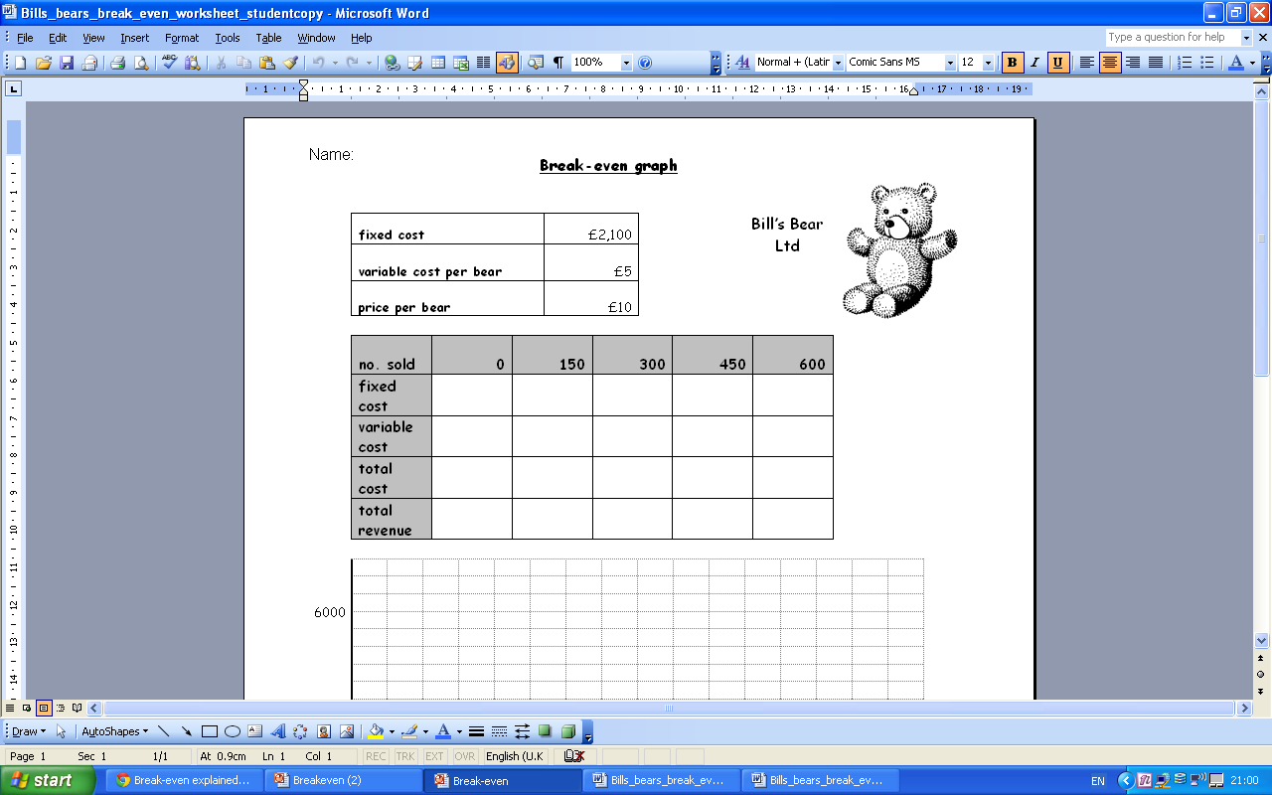

1. Define fixed and variable costs
2. Be able to identify fixed and variable costs
3. Be able to calculate a business’s breakeven point, using the break even formula
4. Understand what the breakeven point shows and why businesses do it.
5. Be able to complete a break even table
6. Understand the break even table; use the table to identify when a business does break even.
7. Be able to draw and fully label a break even graph
8. Be able to calculate a business’s margin of safety and show this on a BE graph
9. Understand and explain how a change in either fixed, variable or selling price can effect/ change the breakeven point and profits.

Exam Questions

A business breaks even at the level of output where:

Select **one** answer.

**A** total profits = total costs

**B** fixed costs = total revenue

**C** variable costs = fixed costs

**D** total revenue = total costs.

(1mark)

Financing Growth

What is the difference between Internal and External Sources of Finance?

Types of Finance:

|  |  |
| --- | --- |
| Internal | External |
|  |  |
|  |  |
|  |  |
|  |  |

Revision Questions

1. Be able to define the internal and external sources of finance

|  |  |
| --- | --- |
| Internal sources of finance | External sources of finance |
| Retained profits  Sales of assets  Owners funds | Share capital  Bank loan  Overdraft  Trade credit |

1. Be able to give at least 2-3 advantages and disadvantages of each types of internal and external source of finance.

**Exam Questions**

Business finance can come from either internal or external sources.

(a) Which of the following is an internal source of finance?

Select **one** answer. (1 mark)

**A** A loan from a bank.

**B** An overdraft.

**C** Selling assets.

**D** A stock market flotation.

(b) Give **one** advantage of using retained profit as a way of financing business

growth. (1 mark)

Identify **one** internal source of finance which *The Range* might use to expand

its business. (1 mark)

(ii) Explain **one** benefit to *The Range* of using internal sources of finance for

Growth. (3 marks)